**VIETNAM NATIONAL UNIVERSITY – HO CHI MINH CITY**

**INTERNATIONAL UNIVERSITY**

**SCHOOL OF BIOMEDICAL ENGINEERING**

**Course of Medical Design (BM017IU)**

**Semester 1, 2024-2025**

**ASSIGNMENT**

**Submitted by**

Nguyễn Thị Hoa - BEBEIU21214

Nguyễn Hoàng Cầm - BEBEIU21177

Đinh Nam Đan - BEBEIU21199

Đặng ngọc Vân Anh - BEBEIU21183

Date Submitted: 29/11/2024

Date Performed: 24/11/2024

Lab Section: Saturday afternoon

Course Instructor: Tran Le Giang, PhD.

TAs: Ta Minh Tri

Do Vy Ngoc

Nguyen Nhat Minh

**Question: a brief introduction about your group final project, your flow chart, block diagram, state diagram.**

**A brief introduction about our group final project**

Our major goal in this project is to develop a syringe pump with high precision, flexibility, and customizable features, applicable to a wide range of usage scenarios. Users can employ various types of cylinders, flexibly modify the volume to be pumped on each infusion, halt or reverse the direction of the cylinder's plunger, and make emergency stops at any time by permitting control through a mobile application. Moreover, all relevant technical parameters will be displayed on both the control application screen on the mobile phone and the LCD screen on the device.

In this project, our group will use microstepping to control the syringe pump’s motor. Microstepping is the best option for managing a stepper motor in a syringe pump. Since microstepping gives stepper motors the most control and accuracy possible, syringe pumps gain much from it. When working with sensitive or low-volume applications, it allows the motor to move in exceedingly small steps, ensuring precise and fluid-delivery-free operations. Microstepping also lessens vibration and noise, which is essential for maintaining the fluid's integrity and preventing any potential disruptions to scientific or medical processes.

**Flowchart**

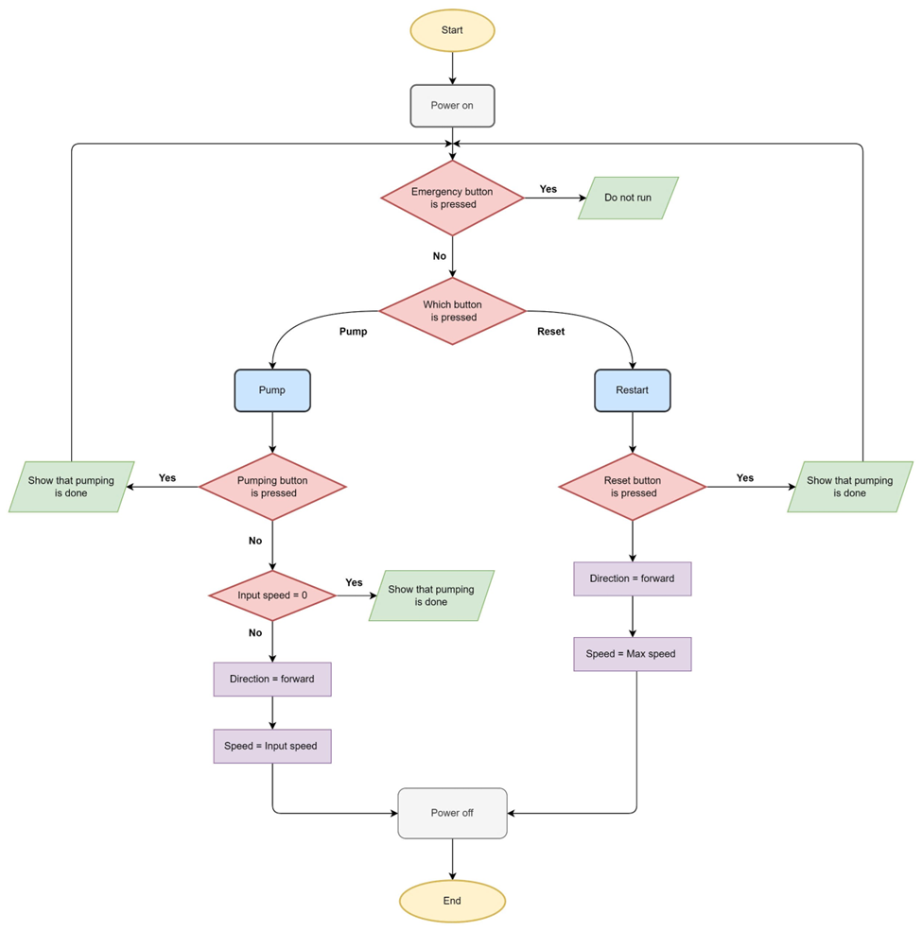

*Figure 1: the flowchart of a syringe pump.*

**Block diagram** 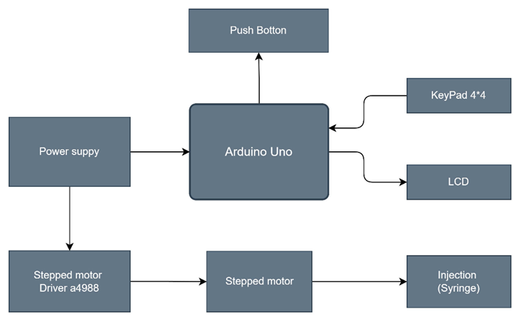

*Figure 2: block diagram of a syringe pump.*

**State diagram**

*Figure 3: block diagram of a syringe pump.*